Safeguarding policy.
This policy sets out the safeguarding standards we expect of our staff when concerns are reported, and how we look to continuously learn and improve our safeguarding practice.
This policy is underpinned by the following legislation and guidance
- The Children Act 1989 and 2004
- Counter terrorism and Security Act 2015 -Prevent Duty
- Female Genital Mutilation Act 2003
- Serious Crime Act 2015
- The Rehabilitation of Offenders Act 1974
- Schedule 4 of the Safeguarding Vulnerable groups Act 2006
- Keeping Children Safe in Education 2022

The designated safeguarding lead is Emma Hughes. The job description for this role is in appendix A
The Deputy Safeguarding Lead is Stanislav Kudym (DDSL)
Definitions.
When we refer to staff, we mean all adults who work for the organisation in an employed or voluntary position and Trustees. Please see appendix B Organisation chart and Board of Trustee details.
When we refer to children, we mean all children who are service users. We consider children and young people to be under 18 years of age.
When we refer to adults, we mean all adults who are service users and or are vulnerable
When we refer to everyone, we mean staff, adults, children, vulnerable adults and trustees
When we use the term abuse, we include harm which may be;
- Verbal
- physical
- sexual
- emotional
- neglect
- peer on peer abuse
- bullying
- child sexual exploitation
- domestic abuse
- drugs and or substance abuse
- fabricated or induced illness
- faith abuse
- female genital mutilation
- forced marriage
- gang and youth violence
- criminal sexual exploitation
- private fostering
- radicalisation
- relationship abuse
- sexting
- trafficking
- cyber bullying
- online abuse
- homophobic abuse
- racist abuse
- disability abuse

What we believe.
We believe that everyone who engages with us has a right to be safe from harm and abuse. This policy is focused on the adults and children we seek to help, regardless of race, age, disability, gender, sexual orientation, ethnicity, and religion, who has contact with us, including through our partners.
Safeguarding is at the heart of what we do at Shropshire Supports Refugees. This policy is crucial to delivering on the commitment to provide a safe and secure environment; and dictates the actions we take when concerns are reported.
Child abuse is defined as any form of maltreatment of a child. This can be abuse or neglect of a child by inflicting harm, or by failing to act to prevent harm. Children may be abused in a family or in an institutional or community setting, by those known to them or, more rarely, by others. Abuse can take place online, or by using technology to facilitate offline abuse. Children may be abused by an adult or adults, or another child or children. Adult abuse is the violation of an individual’s human and civil rights by any other person or persons. We take safeguarding adults to mean upholding the rights of adults to live in safety, free from abuse and neglect. To achieve this, we may take or prompt action to minimise risks, prevent and/or stop abuse and/or neglect.
Our safeguarding arrangements promote the adult’s wellbeing. Being safe is only one of many things that adults want for themselves, and it can be challenging to balance safety and freedom in a way which protects and fulfils human rights. We must work with each adult to establish what being safe means to them and how that can be best achieved. We do this by ensuring that the staff who work with adults are well-trained and well placed to meet the adult’s needs. All new staff are provided with basic safeguarding training before having face-to-face contact with service users.
Safeguarding adults is the term we use to describe all the work we (and others do) to help adults at risk to make their own informed safeguarding decisions and to prompt or take action to protect adults who are not able to protect themselves.
We are committed to being transparent in our safeguarding work and strive for the highest standards of safeguarding through policy, training and induction of staff.
We expect our staff, and our partners, to understand their responsibilities, and to know how to respond when they have a safeguarding concern, or when a safeguarding concern is raised.
All staff and partners are provided with a copy of this document.

The impact of abuse
The impact of abuse should not be underestimated. Many children do recover well and go on to lead healthy, happy and productive lives, although most adult survivors agree that the emotional scars remain, however well buried. For some children, full recovery is beyond their reach, and the rest of their childhood and their adulthood may be characterised by anxiety or depression, self-harm, eating disorders, alcohol and substance misuse, unequal and destructive relationships and long-term medical or psychiatric difficulties. In endorsing this policy, we commit to putting the protection of children who have suffered or are at risk of suffering abuse firmly on the organisation’s agenda and the organisation further commits to ensuring that staff share information with other agencies. Staff should not use confidentiality or data protection as a reason for not sharing. All suspicions or allegations of abuse will be recorded and reported in line with this policy.

Adults.
We have significant contact with adults in a number of different contexts and we believe that they all have an equal right to protection irrespective of their gender, disability, ethnicity, sexuality, religion or age. This policy will be applied to all adults without discrimination. We will support adults to make their own informed safeguarding decisions in line with this policy, the local authority safeguarding adult’s policy.

The Board of Trustees, in partnership with the CEOs and the DSL, are deeply committed to providing a safe and secure environment for our staff and everyone who engages with us and are responsible for ensuring that the organisation has appropriate policies and arrangements in place. This includes ensuring we uphold the organisational values, and that the adults and children we help are at the heart of what we do.

Adults at Risk.
We use the Definitions of ‘adult at risk’ when making a referral to a local authority team (safeguarding adults or adult social care) It’s important to know before the call is made if the adult you're concerned about meets the statutory definition of an adult at risk. This definition differs from country to country. In England the safeguarding duties in the Care Act 2014 apply to an adult who:
• Has needs for care and support (whether or not the local authority is meeting any of those needs); and:
• Is experiencing, or at risk of, abuse or neglect; and;
• As a result of those care and support needs are unable to protect themselves from either the risk of, or the experience of abuse or neglect.
An adult may be a risk of harm or abuse because of personal characteristics, which may include, but are not limited to
- Age,
- Disability,
- Special educational needs,
- Illness,
- Mental or physical frailty or impairment of, or disturbance in, the functioning of the mind or brain.

Staff.
We expect all of our staff to act with integrity as professional representatives of the organisation. We also expect our staff to understand how their personal behaviour affects the adults and children who use our services; particularly in the context of working with children and adults at risk. All staff are given a copy of the Employee Handbook which sets out the standards of conduct we expect from our staff.

Taking action
Key points to remember for taking action are:
- Where an adult or child is at risk of great harm, take the action necessary to prevent further harm to the adult or child, for example, you may need to call 999.
- Report your concern to the DSL immediately if the DSL is not able to be contacted report the concern to the DDSL. If you are unable to report your concern you may need to take action and report the concern to the relevant Local Authority Safeguarding children to Adult Board. Numbers for both of these are at the end of this document.
- Where there is an allegation or suspicion of abuse about a staff member we will contact the LADO for advice and guidance.
- Only share information on a need-to-know basis, however, be aware that those who seek to harm or abuse others rely on others to keep their acts confidential or secret.
- Use the correct documentation to record your concern, see Appendix C Concern Reporting Form.

If a person tells you that they’ve been abused
It takes a lot of courage for a person to tell someone that they are being abused. They may feel ashamed, particularly if the abuse is sexual, their abuser may have threatened what will happen if they tell, they may have lost all trust in adults, or they may believe, or have been told, that the abuse is their own fault.
All staff should be able to reassure victims that they are being taken seriously and that they will be supported and kept safe. A victim should never be given the impression that they are creating a problem by reporting abuse. Nor should a victim ever be made to feel ashamed for making a report. Abuse occurring outside of our agency that does not involve our staff or adults will be dealt with in the same way.

There are many safeguarding issues, affecting adults and children, other than those documented here, that may present in children and or their families. Staff can go to GOV.UK for help and guidance for these specific topics. These include

- Bullying, including cyberbullying
- Physical abuse
- Neglect
- Sexual abuse
- Emotional abuse
- Children missing education
- Child missing from home or care
- Child sexual exploitation
- Domestic violence/abuse
- Drugs/substance abuse
- Fabricated or induced illness
- Faith abuse
- Female genital mutilation
- Forced marriage
- Gangs and youth violence
- Gender-based violence/violence against women and girls
- Hate
- Mental health
- Missing children and adults
- Criminal and sexual exploitation
- Private fostering
- Preventing radicalization/extremism
- Relationship abuse
- Sexting
- Trafficking

Managing allegations of abuse made against staff
As part of our approach to safeguarding, Shropshire Supports Refugees will ensure that we promote an open and transparent culture in which all concerns about all adults working with us are dealt with promptly and appropriately.
There are two levels of concern;
  - Allegations that may meet the harms threshold.
  - Allegation/concerns that do not meet the harms threshold – which may be referred to as ‘low level concerns’.
Allegations which might indicate that a person would pose a risk of harm to children if they continue to work in regular or close contact with children in their present position will be taken seriously. Staff must report their concerns to the DSL in the first instance. The DSL will contact the Local Authority Designated Officer (LADO) for advice and guidance and will follow the advice. We have a duty to inform the local Authority of any serious allegations made against a person which suggests he or she has:

- Behaved in a way that has harmed a child, or may have harmed a child;
- Possibly committed a criminal offence against or related to a child; or
- Behaved towards a child or children in a way that indicates he or she would pose a risk of harm to children; or
- Behaved or may have behaved in a way that indicates they may not be suitable to work with children.

We also have a duty of care towards our staff. We provide support for anyone facing an allegation and provide employees with a named contact if they are suspended. It is essential that any allegations of abuse made against members of staff or volunteers are dealt with very quickly, in a fair and consistent way that provides effective protection for the child and at the same time supports the person who is the subject of the allegation.
In the event of allegations of abuse being made against the Designated Safeguarding Lead (DSL) then allegations should be reported directly to the Deputy Designated Safeguarding Lead (DDSL) the DDSL may consider discussing any concerns with the trustee with responsibility for safeguarding, however, this process must not inhibit or delay the natural process of responding to an allegation.

If the member of staff/volunteer is found to be a risk to children and vulnerable adults, the Disclosure & Barring Service will be notified. The DSL or the DDSL will make the referral. If we are aware of the details of a child who has or may have been harmed by a member of staff or volunteer, we will contact Compass to make a referral to seek support for the child.
There is a legal requirement for employers to make a referral to the DBS where they think that an individual has engaged in conduct that harmed (or is likely to harm) a child; or if a person otherwise poses a risk of harm to a child. Safeguarding Vulnerable Groups Act 2006

Whistleblowing
Whistle blowing is a mechanism by which adults can voice their concerns in good faith, without fear of repercussion. Any behaviour by colleagues that raises concern regardless of source will be recorded and reported to the DSL who will make a decision about the course of action.
Safe Recruitment of Staff Policy
We maintain a central register of details of all staff. This includes the details and results of the check we make before employment commences. All offers of employment are on condition of satisfactory references and clear checks being returned.

This safeguarding policy sets out guidelines and procedures for all staff and trustees to follow.
The policy will be reviewed at least every twelve months and always after a serious safeguarding incident.

Policy dated: February 2026
Review date: February 2027

Updated: June 2026 - EH
Apendix A: DSL Role Description

Designated Safeguarding Lead Job Description

Purpose of the role
To take the lead in ensuring that appropriate arrangements for keeping people safe are in place at Shropshire Supports Refugees.
To promote the safety and welfare of people involved in Shropshire Supports Refugees activities at all times.

Duties and responsibilities
1. Take a lead role in developing and reviewing Shropshire Supports Refugees safeguarding policies and procedures.

2. Take a lead role in implementing Shropshire Supports Refugees safeguarding policies and procedures: ensuring all safeguarding concerning people who take part in Shropshire Supports Refugees activities are responded to appropriately.

3. Make sure that everyone working or volunteering with or for people at Shropshire Supports Refugees, including the board of trustees, understands the safeguarding policy and procedures and knows what to do if they have concerns about a person's welfare.

4. Make sure people who are involved in activities at Shropshire Supports Refugees know who they can talk to if they have a welfare concern and understand what action the organisation will take in response.

5. Receive and record information from anyone who has concerns about a person who takes part in Shropshire Supports Refugees activities.

6. Take the lead on responding to information that may constitute safeguarding concern, including a concern that an adult involved with Shropshire Supports Refugees may present a risk to persons/people.
This includes:
a. assessing and clarifying the information
b. making referrals to statutory organisations as appropriate
c. consulting with and informing the relevant members of the organisation’s management
d. following the organisation’s safeguarding policy and procedures

7. Liaise with, pass on information to and receive information from statutory safeguarding agencies such as: a. the local authority b. the police. This includes making formal referrals to agencies when necessary.

8. Store and retain safeguarding records according to legal requirements and Shropshire Supports Refugees safeguarding policy and procedures.

9. Work closely with the board of trustees to ensure they are kept up to date with safeguarding issues and are fully informed of any concerns about organisational safeguarding practice.

10. Report regularly to the board of trustees on issues relating to safeguarding to ensure that safeguarding is seen as an ongoing priority issue and that safeguarding requirements are being followed at all levels of the organisation.

12. Be familiar with and work within inter-agency safeguarding procedures developed by other local agencies.

13. Be familiar with issues relating to safeguarding, and keep up to date with new developments in this area.

14. Attend regular training in issues relevant to safeguarding and share knowledge from that training with everyone who works or volunteers with or for people at Shropshire Supports Refugees.

15. Attend team meetings, supervision sessions and management meetings as arranged.

16. Work flexibly as may be required and carry out any other reasonable duties.

Appendix B: Staff Organisational Chart

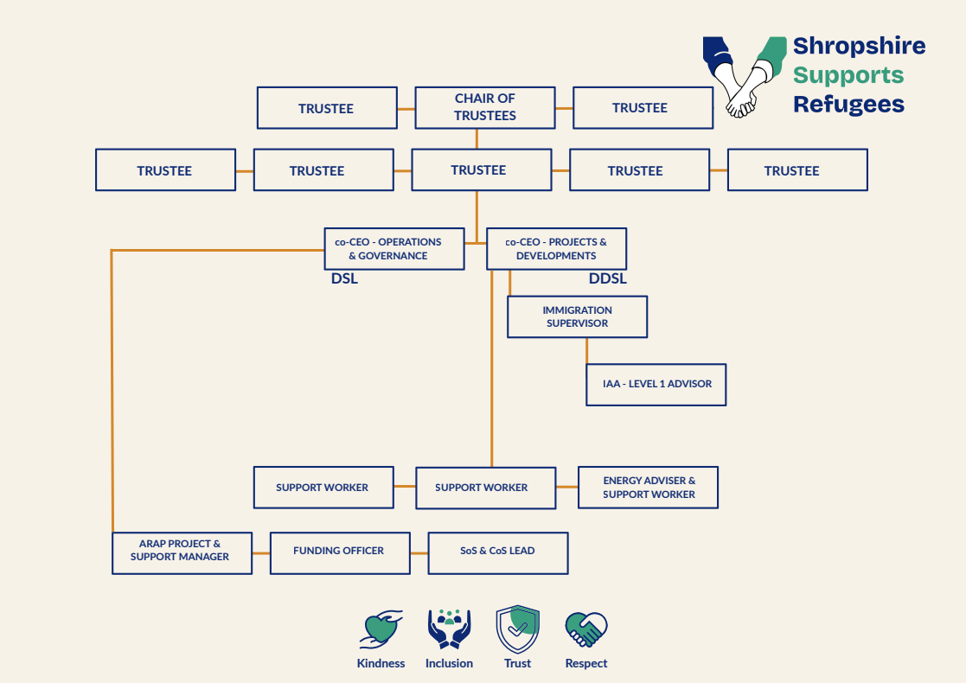

Trustee for Safeguarding:

Jane Smalley

Chair of Trustees:

Martin Hamilton

Appendix C: Concern Reporting Form

Recording Form for Safeguarding Concerns
Staff, volunteers and regular visitors are required to complete this form if they have a safeguarding concern.
All safeguarding concerns should be reported to Louise Watts (Designated Safeguarding Lead) & Emma Hughes (Deputy Safeguarding Lead) within one working day of the incident. In case of emergency, you should inform relevant services such as social services or the police, as soon as possible (which may be in advance of completing this form).
Information Required | Enter Information Here
Name and position of person completing the form:
Date form completed:
Name of the person affected:
Contact details for the person affected (address, phone, email):
Time & date of incident:
Nature of incident:
Time received by DSL
Action Taken by DSL
Any other information

